4th Grade Art Projects
(these are suggested months in which to conduct these lessons, based on the type of project it is. Teachers should be consulted to ensure that these are the projects they want in their classrooms. One teacher from each grade can be the facilitator of the conversation with their cohorts)
October: Batiking Sunflowers
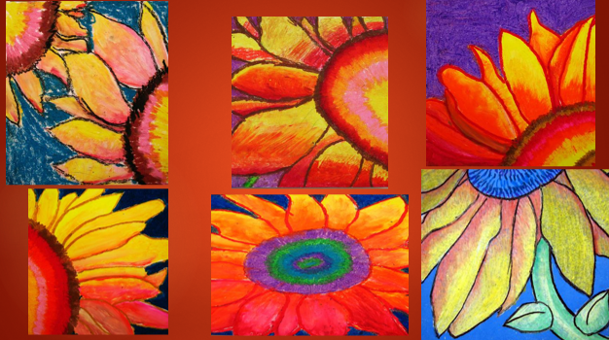
November: KLIMT Tree of Life
(Metallic sharpie and sequins on black paper)
Elements of Art: (line, shape, form, texture, space and color)
Principles of Design: (balance, contrast, emphasis/dominance, movement, pattern, proportion, rhythm, and unity)
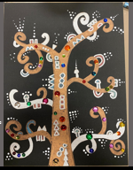
December: Foil Art
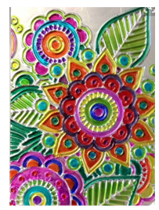

January: Warhol Portrait (requires: prework to complete this project.)
1 – Take a portrait photo of each student and print it on standard letter size paper to use to trace their portrait.
2- students type on a computer and print out their work. No bigger than size 16 font, free write lines of text about their favorite games, foods, activities, places to go, sports, etc. Copy the lines and paste repeatedly until full page of text is created. Print on 8.5 x 11 paper.

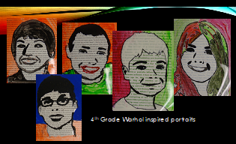
February: Zentangle Hand Silhouette
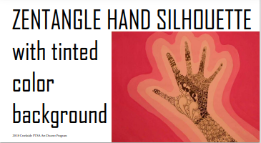

March: NW Coast Native Designs Animals
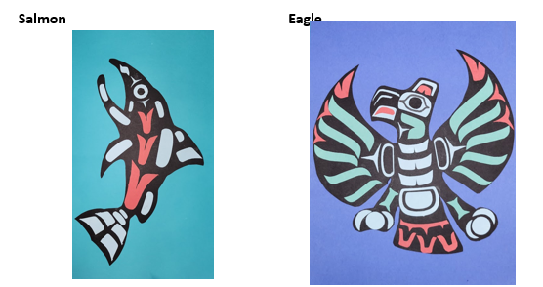

April: Clay
Clay Taco Dragon
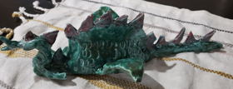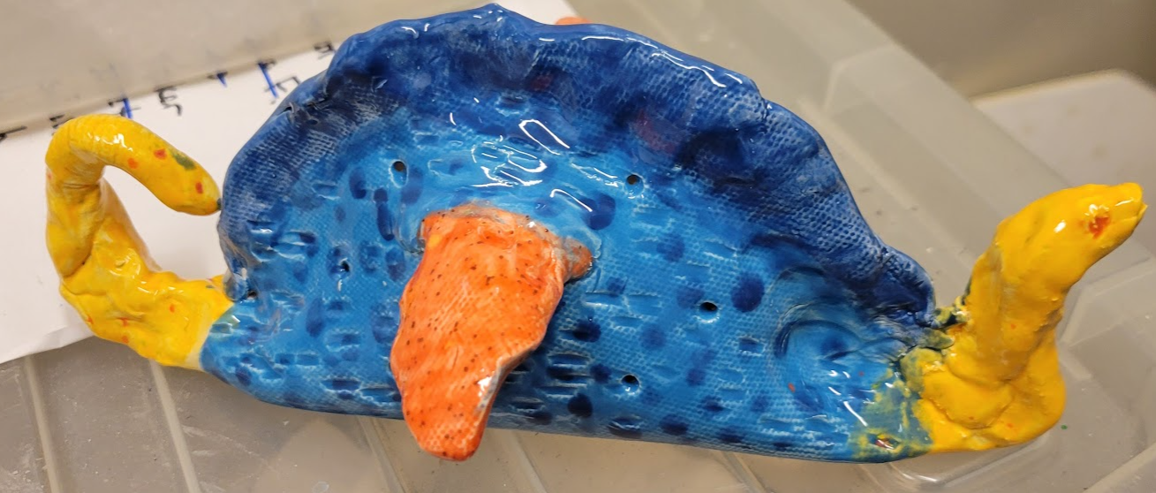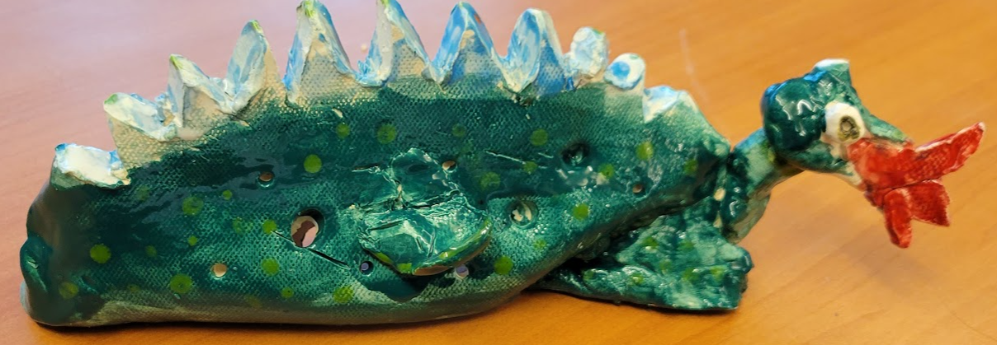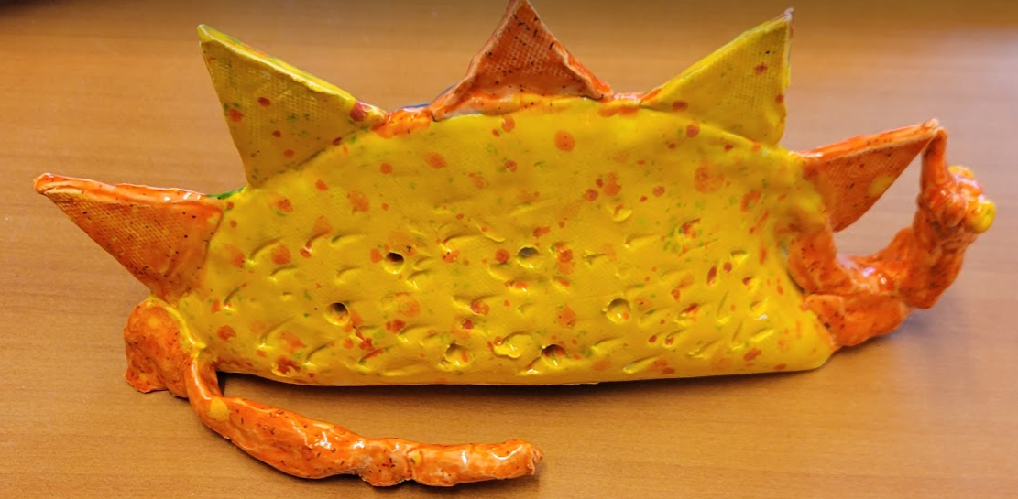

May: Native American Teepees
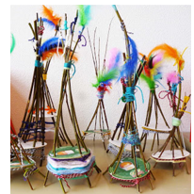

Additional Art Project Ideas:
OP Art Tunnel
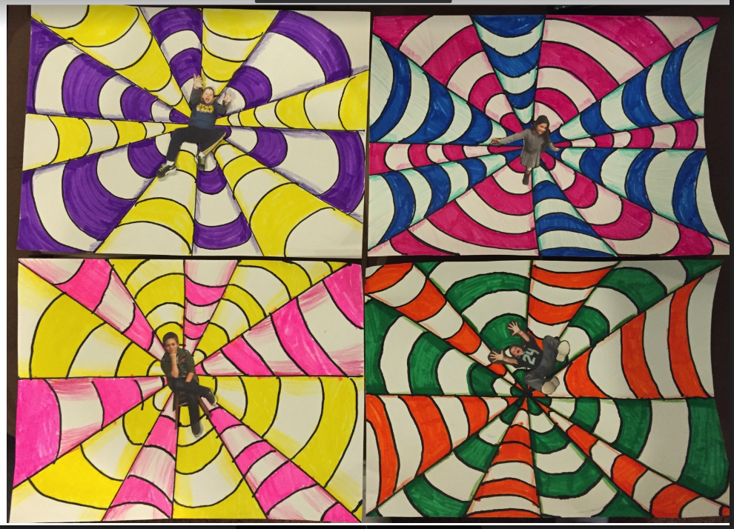

Chilly Bears
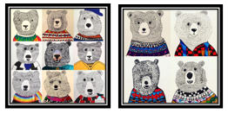
Foil Figures
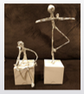

Color Value Silhouettes
